Sample Short-Answer Questions

1. (4pts) For the following code show what the order of the output will be.

**public** **class** MidtermSuperClass {

**static** **int** *superInt* = *superIntMethod*();

**static** **int** superIntMethod(){

System.***out***.println("Initializing variable superInt");

**return** 1;

}

MidtermSuperClass(){

System.***out***.println("Running midtermsuperclass constructor");}

}

**public** **class** Main {

**public** **static** **void** main(String[] args) {

MidtermSuperClass mySuper = **new** MidtermSubClass();

}}

**public** **class** MidtermSubClass **extends** MidtermSuperClass{

**static** **int** *subInt* = *subIntMethod*();

**static** **int** subIntMethod(){

System.***out***.println("Initializing variable subInt");

**return** 2;

}

MidtermSubClass(){

System.***out***.println("Running midtermsubclass constructor");

}}

*Initializing variable superInt*

*Initializing variable subInt*

*Running midtermsuperclass constructor*

*Running midtermsubclass constructor*

1. (2pts) In the following code, describe the relationship between Employer and Gardener.

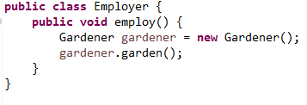

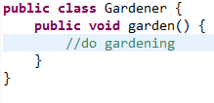

*There is a dependency from Employer to Gardener*

1. (4pts) Describe the relationship between A and B from the following class diagram. Explain what must be in the code for each instance of A and B and explain any constraints on their constructors.

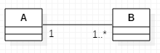

*Each instance of the class A contains a list of instances of B.*

*Each instance of B contains exactly 1 reference to class A.*

*If an instance of A has been created, at least one instance of B has also been created. If an instance of B has been created one instance of A has also been created.*

1. (6pts) What is the OOD Open-Closed Principle? Write some simple code fragments showing a good example coding to the Open-Closed Principle for a problem where we compute the areas of shapes. Shapes can be circles, rectangles, or squares for this problem.
2. (8pts)Show a UML class diagram for the Object Creation Factory Pattern. Create a simple example of this pattern and write enough code in each of your classes that shows the scenario of creating one concrete class. Just a few lines of code for each of your classes is enough to show your design.

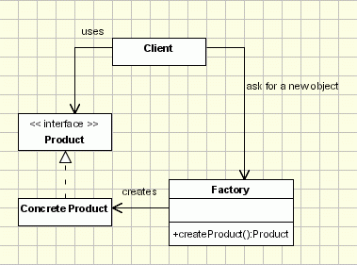

Sample Code:

public class FactoryClient {

public static void main(String[] args) {

Product mtnBike;

ProductFactory myProductFactory = new ProductFactory();

mtnBike = myProductFactory.createProduct("MtnBike");

if (mtnBike != null)

System.out.println(mtnBike.getProductPrice());

}}

public class MtnBike implements Product {

@Override

public double getProductPrice() {

return 300.00;

}}

public interface Product {

public double getProductPrice();

}

public class ProductFactory {

public Product createProduct(String productType){

if (productType.equals("MtnBike"))

return new MtnBike();

else

return null;

}}

1. (2pts)What is the “diamond problem?” Draw a diagram showing the problem.

